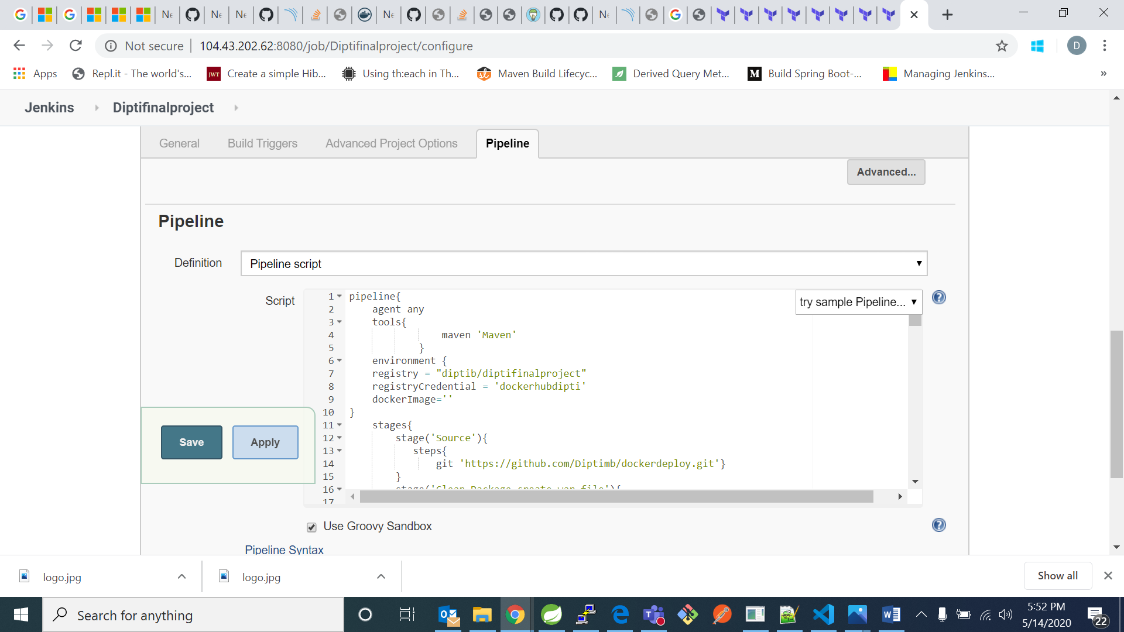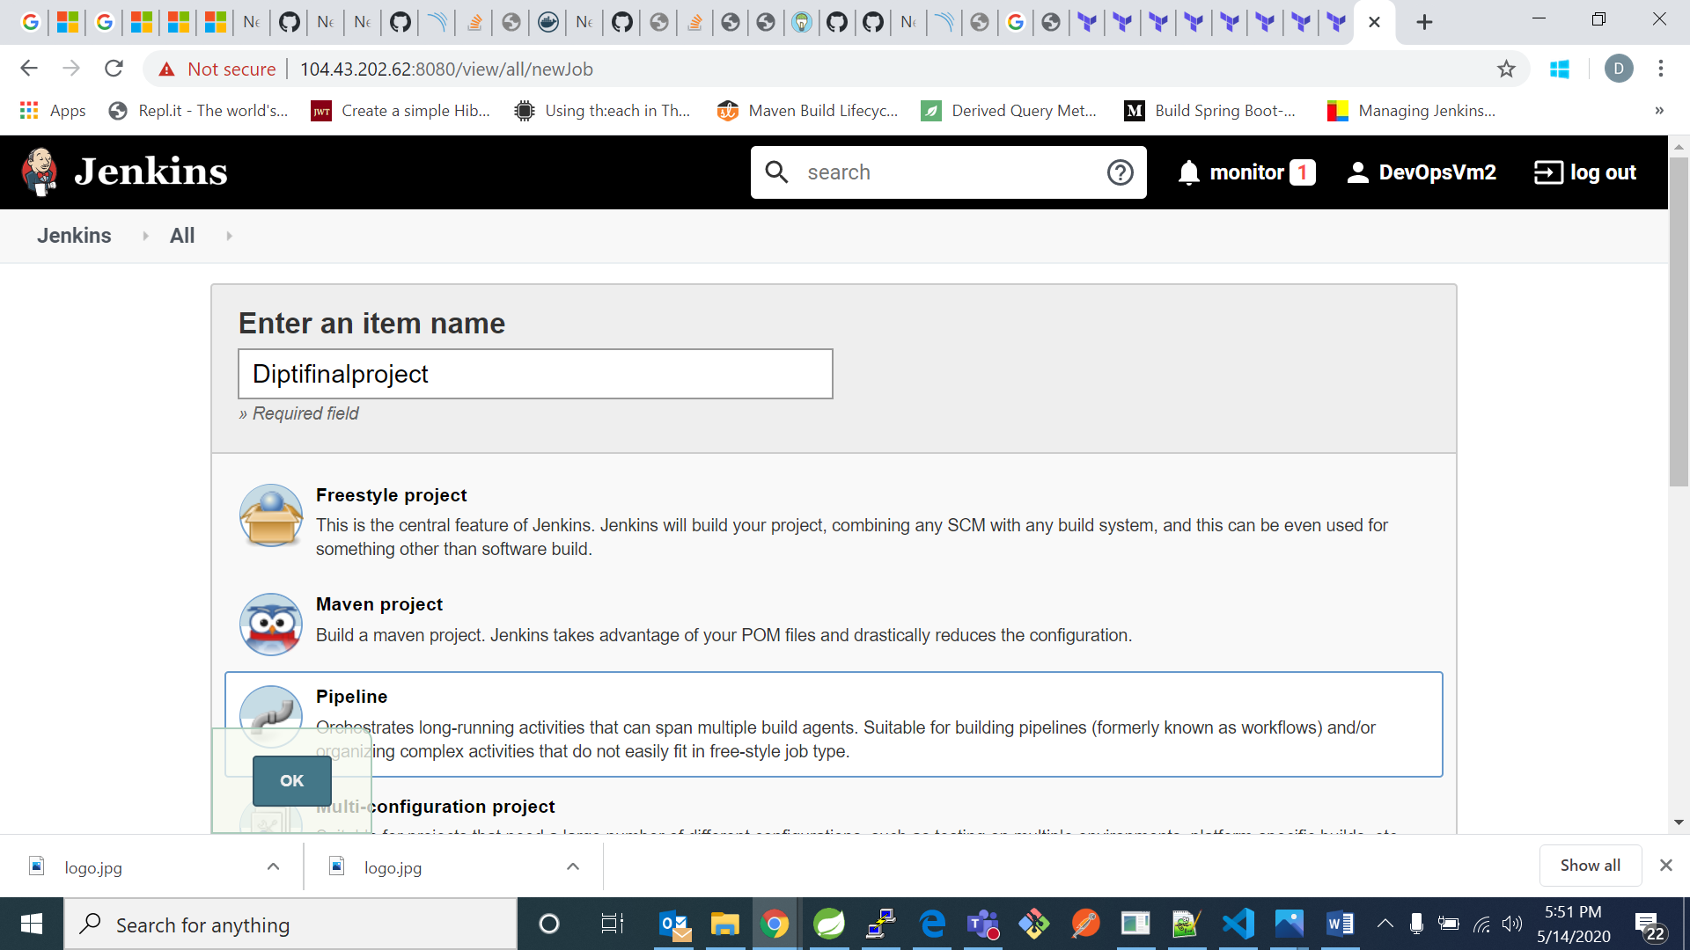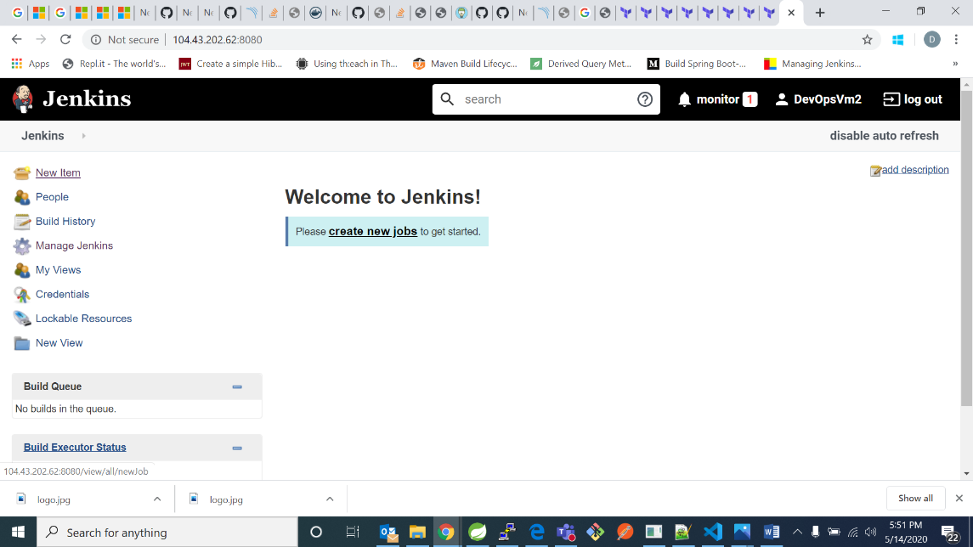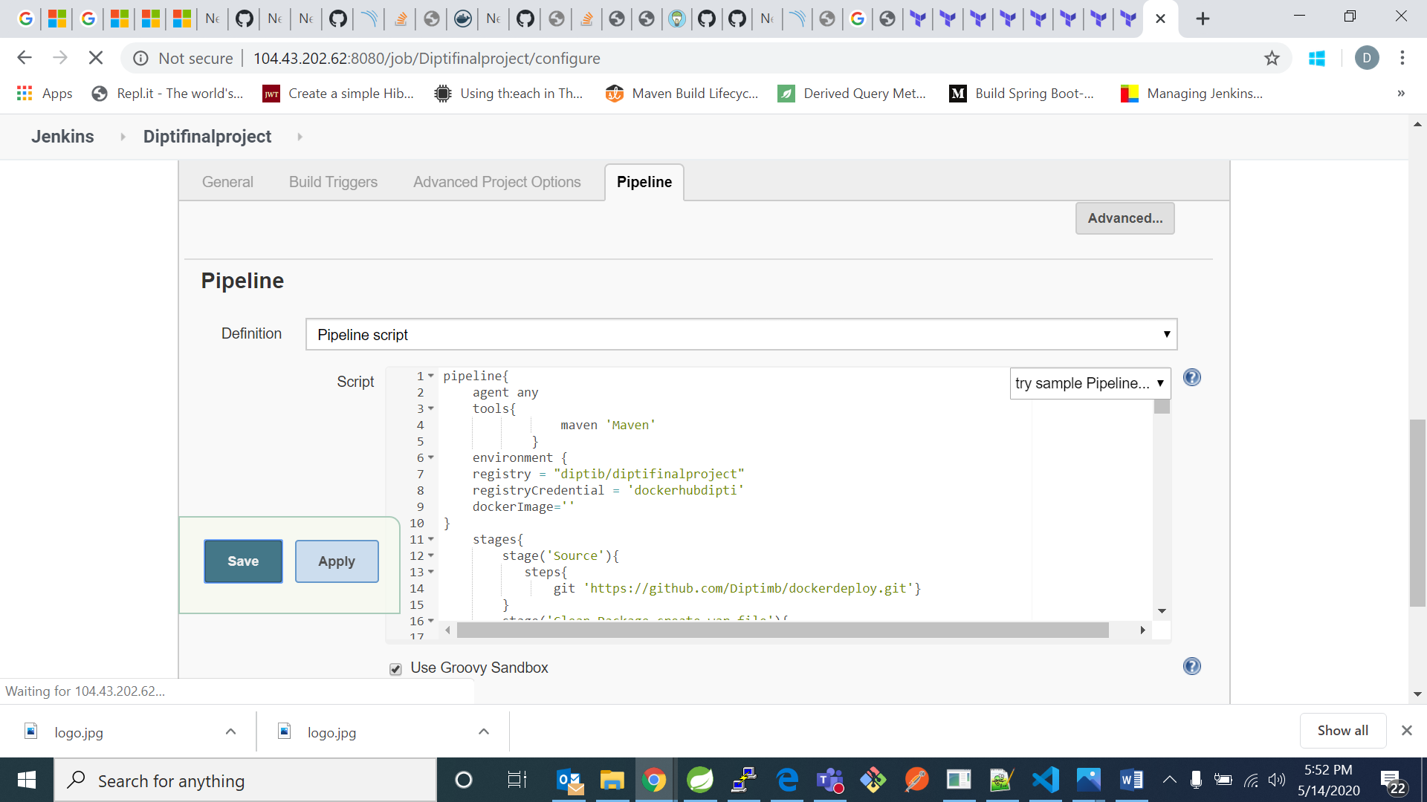

pipeline{

agent any

tools{

maven 'Maven'

}

environment {

registry = "diptib/diptifinalproject"

registryCredential = 'dockerhubdipti'

dockerImage=''

}

stages{

stage('Source'){

steps{

git 'https://github.com/Diptimb/dockerdeploy.git'}

}

stage('Clean-Package-create-war-file'){

steps{

sh 'mvn clean package -Dmaven.test.skip=true'

}

}

stage('Sonar Analysis'){

steps{

script {

Pipeline_Message=env.STAGE_NAME

echo "Sonar Analysis"

}

dir("/var/lib/jenkins/workspace/Diptifinalproject")

{

withSonarQubeEnv('sonarqube')

{

sh 'mvn sonar:sonar'

}

}

}

}

stage('Quality Gate')

{

steps

{

script

{

timeout(time: 1, unit: 'HOURS')

{

def qg = waitForQualityGate()

if (qg.status != 'OK')

{

error "Pipeline aborted due to quality gate failure: ${qg.status}"

mail bcc: '', body: 'quality gate pass failed', cc: '', from: '', replyTo: '',

subject: 'Gate passing Failed', to: 'deepubebarta@gmail.com'

currentBuild.status='FAILURE'

}

}

}

}}

stage ('upload') {

steps{

script {

def server = Artifactory.server "1"

def buildInfo = Artifactory.newBuildInfo()

buildInfo.env.capture = true

buildInfo.env.collect()

def uploadSpec = """{

"files": [ {

"pattern": "**/target/*.war",

"target": "libs-snapshot-local"}]

}"""

server.upload spec: uploadSpec, buildInfo: buildInfo

server.publishBuildInfo buildInfo

}}}

stage('Build image') {

steps {

echo 'Starting to build docker image'

script {

dockerImage= docker.build registry + ":$BUILD_NUMBER"

}

}

}

stage('Push Image') {

steps{

script {

sh 'docker login -u "diptib" -p "123456789" docker.io && docker push diptib/diptifinalproject'

docker.withRegistry( '', registryCredential ) {

dockerImage.push()

}

}

}

}

stage ('Deploy')

{

steps{

script{

sh 'docker container run -i --publish 8081:8081 diptib/diptifinalproject:$BUILD_NUMBER'

/*sshagent(['dev-server']) {

sh "ssh -o StrictHostKeyChecking=no DevOpsVm2@104.43.202.62:$dockerRun"

}*/

}

}}

-,

steps{

sh "docker rmi $registry:$BUILD_NUMBER"

}

}

/*stage('Deploy'){

steps{

sh "cp /var/lib/jenkins/workspace/Diptifinalproject/target/*.war /var/lib/tomcat8/webapps"}

}*/

}

post {

always {

mail to: 'deepubebarta@gmail.com',

subject: "Status of pipeline: ${currentBuild.fullDisplayName}",

body: "${env.BUILD_URL} has result ${currentBuild.result}"

}

}

}